Smart Tablet Visitor Guidance System Report

Group 3
Adam Boube, Jared Badger, Angela Karanja, Etsubdek Kidane, Nasir Rainer, Anthony Siegle, Daniel Sunde

Table of Contents

Table of Contents 2
Summary 3
Project Charter 4
Procurement 7
4.1 Request for Proposal (RFP) 7
4.2 Detailed Proposal 13
4.3 Evaluation & Selection 16
Project Plan 17
5.1 Scope Statement 17
5.2 Work Breakdown Structure (WBS) 18
5.3 Task List 23
5.4 Responsibility Matrix 25
5.5 Resources 26
5.6 Schedule 27
5.7 Cost Table 28
5.8 Gantt Chart 30
5.9 Network Diagram 31
5.0 Critical Path 31
Project Closeout 32
Conclusion 32

Summary

This project entails the design and implementation of a smart tablet system that allows visitors of the National Aquarium of Baltimore, Maryland. The goal of this project is to enhance the visitor experience and increase foot traffic within the aquarium. The system will allow for visitors' questions to be answered with easy-to-access information about animals and exhibits while also providing directions within the aquarium's database. The smart tablets will be able to accept voice input as well as touch. This project will align with the mission of the National Aquarium of Baltimore, Maryland which is to inspire the conversation of the world’s aquatic ecosystem.

The IT team will be developing a “rugged”, while at the same time, user-friendly tablet system that allows for the following features:

Interactive Control

Visitors can obtain information about the aquarium, animals, and exhibits using:
- Touch controls
- Voice detection

Smart Navigation:
The tablets will provide directions at the discretion of the visitors to certain exhibits and locations of interest throughout the aquarium.

Personalised Recommendations

Based on questions asked and exhibits interacted with, the tablet system will be able to provide recommendations on exhibits visitors can interact with and gift shop purchases that align with exhibits and topics of interest.

Project Charter

Project Title: Smart Tablet Visitor Guidance System; National Aquarium of Baltimore

Project Start Date: May 20, 2026

Projected Finish Date: May 30th, 2027 (12-month target completion)

Budget Information: Estimated project budget: $450,000 – $600,000 (fixed-price contract)
Includes:
- Hardware procurement (rugged tablets, cases, accessories)
- Software development and integration
- Backend system integration
- Testing, deployment, and training
- Maintenance and support setup
Project Manager: Adam Boube, 4432062142, aboube1@students.towson.edu

Project Objectives:
Improve visitor experience at the National Aquarium through an interactive smart tablet system.
- Provide real-time information about exhibits, animals, and facilities
- Offer indoor navigation and directions within the aquarium
- Enable touch and voice-based interaction for accessibility
- Integrate with existing aquarium databases and systems
- Increase visitor engagement and potentially boost revenue through recommendations (e.g., gift shop suggestions)

Project Deliverables:
- System architecture and technical design documentation
- Fully functional smart tablet application
- Integrated backend database system
- Rugged tablet deployment (Apple iPads with protective cases)
- Navigation and exhibit information system
- Voice and touch interface functionality
- Testing and QA documentation
- Training materials for staff
- Maintenance and support plan
Project Success Criteria:
- The system is fully deployed and functional within 12 months
- 95%+ system uptime during operational hours
- Positive visitor feedback on usability and experience
- Successful integration with aquarium databases
- Accurate navigation and exhibit information delivery
- The system performs reliably under high visitor traffic

Project Acceptance Criteria:
- Final system passes user acceptance testing (UAT)
- All required features are implemented and functional
- Stakeholders approve prototype, design, and final deployment
- No critical system defects at launch
- Training completed for aquarium staff
- Documentation delivered and approved

Roles and Responsibilities:

Role | Name | Organization/Position | Contact Information
Project Manager | Adam Boube | - Define scope  - Manage project plan  - Ensure the project stays within the National Aquarium's mission and goals | Aboube1@students.towson.edu
System Architect | Jared Badger | - Designs system architecture of tablet applications, servers, and networks  - Plan system scalability | Jbadge1@students.towson.edu
Backend Developer | Angela Karanja | - Develop APIs  - Integration of the Aquarium education information database  - Analytic monitoring | akaranj1@students.towson.edu
UI/UX Designer | Etsubdenk Kidane | - Design tablet interface and visual layouts | ekidane2@students.towsn.edu
Integration Specialist | Nasir Rainer | - Integrate the existing education database, retail, and navigation | nrainer1@students.towson.edu
QA/Test Lead | Anthony Sigele | - Develops and executes software testing  - Bridge the gap between technical testing and project management  - Assesses services and products to ensure the standards of the National Aquarium are met | asiegle1@students.towson.edu
Documentation Lead | Daniel Sunde | - In charge of documenting all project phases  - Noting any struggles or delays to the project  - In charge of all important documents accumulated, including RFPs,WBS, schedules, etc. | dsunde2@students.towson.edu

Comments: (comments from above stakeholders, if applicable):

- Project is based on a fixed-price contract model with milestone-based approval
- Emphasis on accessibility, usability, and real-time data integration
- System must support diverse user age groups and technical ability levels
- Solution must be scalable for future expansion across other aquarium systems

Procurement

4.1 Request for Proposal (RFP)

Request for Proposal (RFP)
Smart Tablet System
National Aquarium, Baltimore, Maryland

Introduction
The National Aquarium of Baltimore, Maryland is seeking proposals from qualified vendors to design, implement, and support a “smart” tablet system. This system is to be implemented to enhance the visitor experience by providing interactive, real-time exhibit information, navigation, and building information.
Background
The National Aquarium of Baltimore, Maryland is a private nonprofit organization dedicated to cultivating and inspiring people to connect with nature and inspire care of our oceans across the world. The National Aquarium is located on a 6-acre site in Baltimore’s inner-harbour, home to over 17,000 animals of 750 different species of fish, birds, reptiles, and mammals.
1. Statement of Work (SOW)
The selected vendor will design, develop, implement, and support a smart tablet-based visitor guidance system for the National Aquarium. The system must be able to provide real-time information regarding exhibits and the Aquarium facility. The tablets will be able to be carried by the visitors for the duration of their stay at the facility. The system must also be able to answer any questions and direct visitors to exhibits of interest. Should be able to tie the system into the Aquarium store database for purchase suggestions if questions fall into the scope relevancy.
The work includes software development of the interactive application backend infrastructure, system integration with existing Aquarium databases, deployment, testing, training, and ongoing support. This solution should be to be scalable while at the same usable for users of all ages and technical experience.

2. Customer Requirements
All proposed solutions must provide:
- Accurate, real-time answers to visitors’ questions about animals, exhibits, and Aquarium operations
- Facility navigation capabilities
- Input methods of touch and voice
- Multiple output formats of text, audio, photo, and or video
- Accessible to diverse audiences of differing ages and technical experiences
- Integrate with existing National Aquarium education and information database
- Operate reliably in a high-traffic public environment

3. Deliverables
The vendor will provide:
- System architecture and design documentation
- Fully functional prototype for review
- Completed software application
- Integrated backend system
- Testing and quality assurance reports
- Deployment and installation
- Staff training materials and sessions

4. Customer-Supplied Items
The National Aquarium of Baltimore, Maryland will provide:
- Existing educational and information databases
- Facility maps and exhibit information
- Physical access to the Aquarium for testing and deployment
- Rugged, smart tablets and accessories including tablet cases, stylus and other infrastructure
- Existing IT environment
5. Approvals Required by the Customer
The following milestones will require formal approval:
- System design and architecture
- Prototype/demo system
- User interface and experience design
- Pre-deployment testing results
- Final system acceptance

6. Type of Contract
The National Aquarium will be awarding a fixed-price contract with clearly defined deliverables and milestones. Payments will be attributed upon milestone completion, which includes approval, deployment, and final selected acceptance. The selected vendor will be responsible for development, integrating, testing, deploying, and training throughout the project’s duration.
7. Payment Terms
Payments will be tied to milestone completion, such as:
- Initial design approval
- Prototype delivery
- System development completion
- Deployment and installation
- Final acceptance

8. Schedule for Completion
Potential contractors must provide a schedule for completion that aligns with the National Aquarium’s target schedule.
The target schedule provided by the National Aquarium is as follows:
- Project initiation: Within 10 days of contract award
- Prototype presentation: Within 3–4 months of contract start date
- Full-scale deployment: Within 9–13 months. (No later than 15 months after the scheduled project start date).
- Aiming for full deployment day of May 2027

9. Format and Content of Proposals
Proposals must include:
- Executive summary
- Technical approach and system architecture
- Software functionality overview
- Implementation timeline
- Cost proposal and pricing breakdown

10. Deadline
Proposals must be submitted no later than:
May 12th, 2026, 11:59 PM (EDT)
Late submissions will not be accepted unless there are extenuating circumstances that are discussed before the deadline.

*Submissions must be emailed to the Documentation Lead, Daniel Sunde at dsunde2@students.towson.edu.

11. Evaluation Criteria
All proposals must be extensive and complete with no errors. Presented in a manner that is easy to understand for individuals with varying technical and legal familiarity.
After the first phase of selection, the National Aquarium may require a presentation from potential vendors before the award is granted. Vendors will be contacted if a presentation/demonstration will be required and what date they will be conducted on. Presentations/demonstrations should highlight vendors’ plan of action or any primary visions they may have for the project.

Proposals will be evaluated based on:
- Technical solution quality and feasibility
- Ease of use and visitor experience design
- Cost and overall value
- Long-term sustainability
- System reliability

*To note the proposal must be able to be scaled up or down depending on the needs of the National Aquarium. While also having a high level of usability for visitors of the Aquarium and those a part of the Information Technology Services Department of the National Aquarium.
12. Pre-Awarding Conference
A pre-proposal conference will be held in-person or via Zoom. This conference takes place before the final decision regarding the awarding of the contract. The final 5 vendors will be selected and notified beforehand to prepare a presentation to stakeholders and the Information Technology team of the National Aquarium. This presentation gives vendors a final opportunity to convince the team to award them the contract. Preliminary demonstrations can be included in this conference.

4.2 Detailed Proposal

4.2.1 Technical Section

The proposed solution is the Visitor Guidance System that allows for visitors of the National Aquarium to use while visiting the facility. The tablet system includes rugged tablets that can provide users with information related to exhibits, animals, navigation, and store inventory of the National Aquarium. This information will be within real time, as our visitors navigate the facility in an accessible environment.

We expect the solution to consist of a touchscreen tablet that is capable of enduring daily use within a high traffic environment. Each tablet will be able to connect to the Aquarium’s network and communicate with our applications and databases. The system will also be integrated with our current informative databases to provide efficient access to details regarding animals, exhibits, and FAQs.

The tablets will also be accessibility friendly, supporting multiple forms of interaction. This would include a navigation menu that is touch screen, or a voice only input, to support those with disabilities. Information may also be displayed within a variety of text, graphics, audio, and video clips when necessary. Maps and assistance will also allow our visitors to locate a specific animal or exhibit of their choice, exits, and other facilities in a more efficient manner.

Infrastructure required for the project includes:

- Rugged Visitor Tablets
- Wireless Network Connectivity
- Application Software
- Database Services
- Secure Device Management Software

It is essential that our systems remain reliable, while also adhering to efficiency. We propose that the solution will isolate application servers from the educational systems. This isolation will mitigate the risks of disruptions to our current operations, while allowing the tablet systems to operate independently, especially within a high traffic environment.

4.2.2 Management Section

Management approaches should emphasize planning, testing, risk management, and communication within our stakeholders. The IT department will oversee coordination while partitioning with vendors for development and hardware procurement services.

Project team will consist of the following roles:
- Project Manager
- System Architect
- Backend Developer
- UI/UX Designer
- Integration Specialist
- QA/ Test Lead
- Documentation Lead

The team will begin working in the following steps:
- Requirement Analysis
- System Design
- Vendor Selection
- Software Integration
- Installation
- Testing
- Partial Deployment
- Full Deployment
- Employee Training
- Conclusion / Documentation

To review progress, meetings will be conducted to identify risks, and any technical or schedule concerns. You will be required to submit a progress report regularly to the Aquarium leadership and our project stakeholders.

Activities revolving around risk management will focus on issues like:
- Tablet Damage / Theft
- Connectivity Issues
- Integration Delays
- Over Budget
- Adoption Challenges

4.2.3 Cost Estimate Section

The estimated total costs of this project ranges from $450,000 - $600,000. This reflects expenses including planning, developing, implementation, testing, and deployment.

Major costs include the tablets, wireless environment, software development, the security for our mobile devices, database integration, and employee training. Any additional costs related to management, labour, and documentation are provided to give the best estimate for the technology implemented throughout this project.

This project will also have a reserve to account for the challenges, schedule adjustments, and support that may present itself throughout its duration. This estimated budget will support a reliable guidance system, which is capable of handling high traffic, while also being secure.

4.3 Evaluation & Selection

To ensure that we are deciding for the better of the Aquarium, an evaluation and vendor selection process will occur to identify the contractor that best suits our technical, operational, and financial requirements of this project. Vendors will be evaluated carefully to ensure that the selected solution remains aligned with reliability, cost effectiveness, and is overall aligned with our mission of enhancing our consumer’s experience.

After the RFP is released, vendors will be invited to submit their proposals, which contain our technical requirements, implementation plans, timelines, cost estimates, and support services. All proposals will be reviewed by a leadership member of the Aquarium, IT Services, financial representatives, and stakeholders.

The process will focus on several criteria including:
- Capability and solution quality
- Reliability and scalability
- Efficient accessibility features
- Data protection measures
- Reputation and support services
- Timeline and implementation approach
- Experience within technology projects in a public setting
- Security and data protection approaches

Each proposal will be scored within an evaluation approach to ensure the comparison among our vendors. Those with technical expertise and reliability will be priority as our mission is to complement our visitors with an easy experience throughout the Aquarium.

Criteria | Percentage
Solution Quality | 30%
Cost Effectiveness | 20%
Vendor Experience | 15%
Accessibility Features | 15%
Maintenance | 10%
Reliability | 10%

Vendors may be invited to provide a demonstration of their product, or any other clarification regarding their proposed solution. The final selection will be based on the proposal that has the best balance of overall value regarding reliability, accessibility, implementation, and functionality. Once we select a vendor, negotiations will begin to finalize scope, deliverables, timelines, and budget before implementation activities present themselves.

Project Plan

5.1 Scope Statement

The scope of the National Aquarium Smart Tablet Visitor Guidance System encompasses the activities involved in the planning, designing, development, integration, testing, deployment, and maintenance of a guidance system using smart tablets that can be used by visitors at the National Aquarium. The guidance system would deliver exhibit information, animal facts, navigation assistance, accessible features, and other recommended information via the smart tablets. Other activities within the scope of the project include integration with existing aquarium education databases and gift shop systems, configuration of the wireless network, implementation of the security framework, and testing among others.

The deliverables for the project include an end user tablet application, backend architecture, database implementation, deployment of rugged tablets, installation of charging station, voice and touch functionality, testing documents, maintenance strategy, and training manuals for employees. The system is expected to perform seamlessly in a busy public setting despite the varying ages and technological skills of the visitors.
The scope of this project is restricted to implementing and deploying the smart tablet system in the aquarium. It does not cover any changes in the design of the aquarium exhibit, any physical modification beyond the requirements of deployment, and expansion capabilities beyond what has been planned for this project. Any future additions and enhancements to the system will be treated as separate projects.

5.2 Work Breakdown Structure (WBS)

National Aquarium Smart Tablet System

1. Project Initiation
1.1 Define Project Scope
1.1.1 Identify Project Objectives
1.1.2 Identify Project Deliverables
1.2 Identify Stakeholders
1.2.1 Identify Aquarium Leadership
1.2.2 Identify IT Services Team
1.2.3 Identify Visitor Accessibility Needs
1.3 Create Project Charter
1.3.1 Define Roles and Responsibilities
1.3.2 Define Success Criteria
1.3.3 Obtain Project Approval

2. Requirements Analysis

2.1 Gather Visitor Requirements
2.1.1 Analyze Visitor Information Needs
2.1.2 Analyze Navigation Requirements
2.1.3 Analyze Accessibility Requirements
2.2 Review Existing Systems
2.2.1 Review Educational Databases
2.2.2 Review Existing Network Infrastructure
2.2.3 Review Gift Shop Database Integration
2.3 Define Technical Requirements
2.3.1 Define Hardware Requirements
2.3.2 Define Software Requirements
2.3.3 Define Security Requirements

3. System Design

3.1 Design System Architecture
3.1.1 Design Application Architecture
3.1.2 Design Database Integration
3.1.3 Design Network Infrastructure
3.2 Design User Interface
3.2.1 Design Touchscreen Interface
3.2.2 Design Voice Interaction Features
3.2.3 Design Accessibility Features
3.3 Review and Approve System Design
3.3.1 Conduct Design Review
3.3.2 Approve Final Design Specifications
4. Procurement and Vendor Selection

4.1 Develop Request for Proposal (RFP)
4.1.1 Define Vendor Requirements
4.1.2 Define Proposal Evaluation Criteria
4.2 Evaluate Vendor Proposals
4.2.1 Review Technical Proposals
4.2.2 Review Cost Proposals
4.2.3 Conduct Vendor Demonstrations
4.3 Select Vendors and Procure Equipment
4.3.1 Select Hardware Vendor
4.3.2 Procure Rugged Tablets
4.3.3 Procure Supporting Equipment

5. Infrastructure Setup

5.1 Prepare Server Environment
5.1.1 Configure Backend Servers
5.1.2 Configure Database Services
5.2 Configure Network Infrastructure
5.2.1 Configure Wireless Connectivity
5.2.2 Configure Secure Access Controls
5.3 Prepare Testing Environment
5.3.1 Create Test Environment
5.3.2 Verify Infrastructure Readiness

6. Software Development and Integration

6.1 Develop Tablet Application
6.1.1 Develop Visitor Information Features
6.1.2 Develop Navigation Features
6.1.3 Develop Recommendation Features
6.2 Implement User Interaction Features
6.2.1 Implement Touch Controls
6.2.2 Implement Voice Input Features
6.3 Integrate Existing Systems
6.3.1 Integrate Aquarium Databases
6.3.2 Integrate Gift Shop Systems
6.3.3 Perform System Integration Testing

7. Testing and Quality Assurance
7.1 Develop Testing Plan
7.1.1 Define Testing Procedures
7.1.2 Define Acceptance Criteria
7.2 Conduct System Testing
7.2.1 Conduct Functionality Testing
7.2.2 Conduct Accessibility Testing
7.2.3 Conduct Performance Testing
7.3 Conduct User Acceptance Testing
7.3.1 Collect User Feedback
7.3.2 Resolve Identified Defects
8. Deployment and Implementation Planning

8.1 Prepare Deployment Plan
8.1.1 Define Deployment Procedures
8.1.2 Define Rollback Procedures
8.2 Conduct Pilot Deployment
8.2.1 Deploy Pilot Tablets
8.2.2 Evaluate Pilot Performance
8.3 Prepare Full Deployment
8.3.1 Install Charging Stations
8.3.2 Prepare Production Environment

9. Training and Documentation

9.1 Create Training Materials
9.1.1 Create User Guides
9.1.2 Create Technical Documentation
9.2 Conduct Staff Training
9.2.1 Train Aquarium Staff
9.2.2 Train Technical Support Staff
9.3 Finalize Project Documentation
9.3.1 Compile Maintenance Documentation
9.3.2 Compile Support Documentation

10. Project Closeout

10.1 Conduct Final System Review
10.1.1 Verify Project Deliverables
10.1.2 Review Project Objectives
10.2 Obtain Stakeholder Approval
10.2.1 Conduct Final Approval Meeting
10.2.2 Complete Signoff Process
10.3 Close Project
10.3.1 Document Lessons Learned
10.3.2 Transition System to Support Team

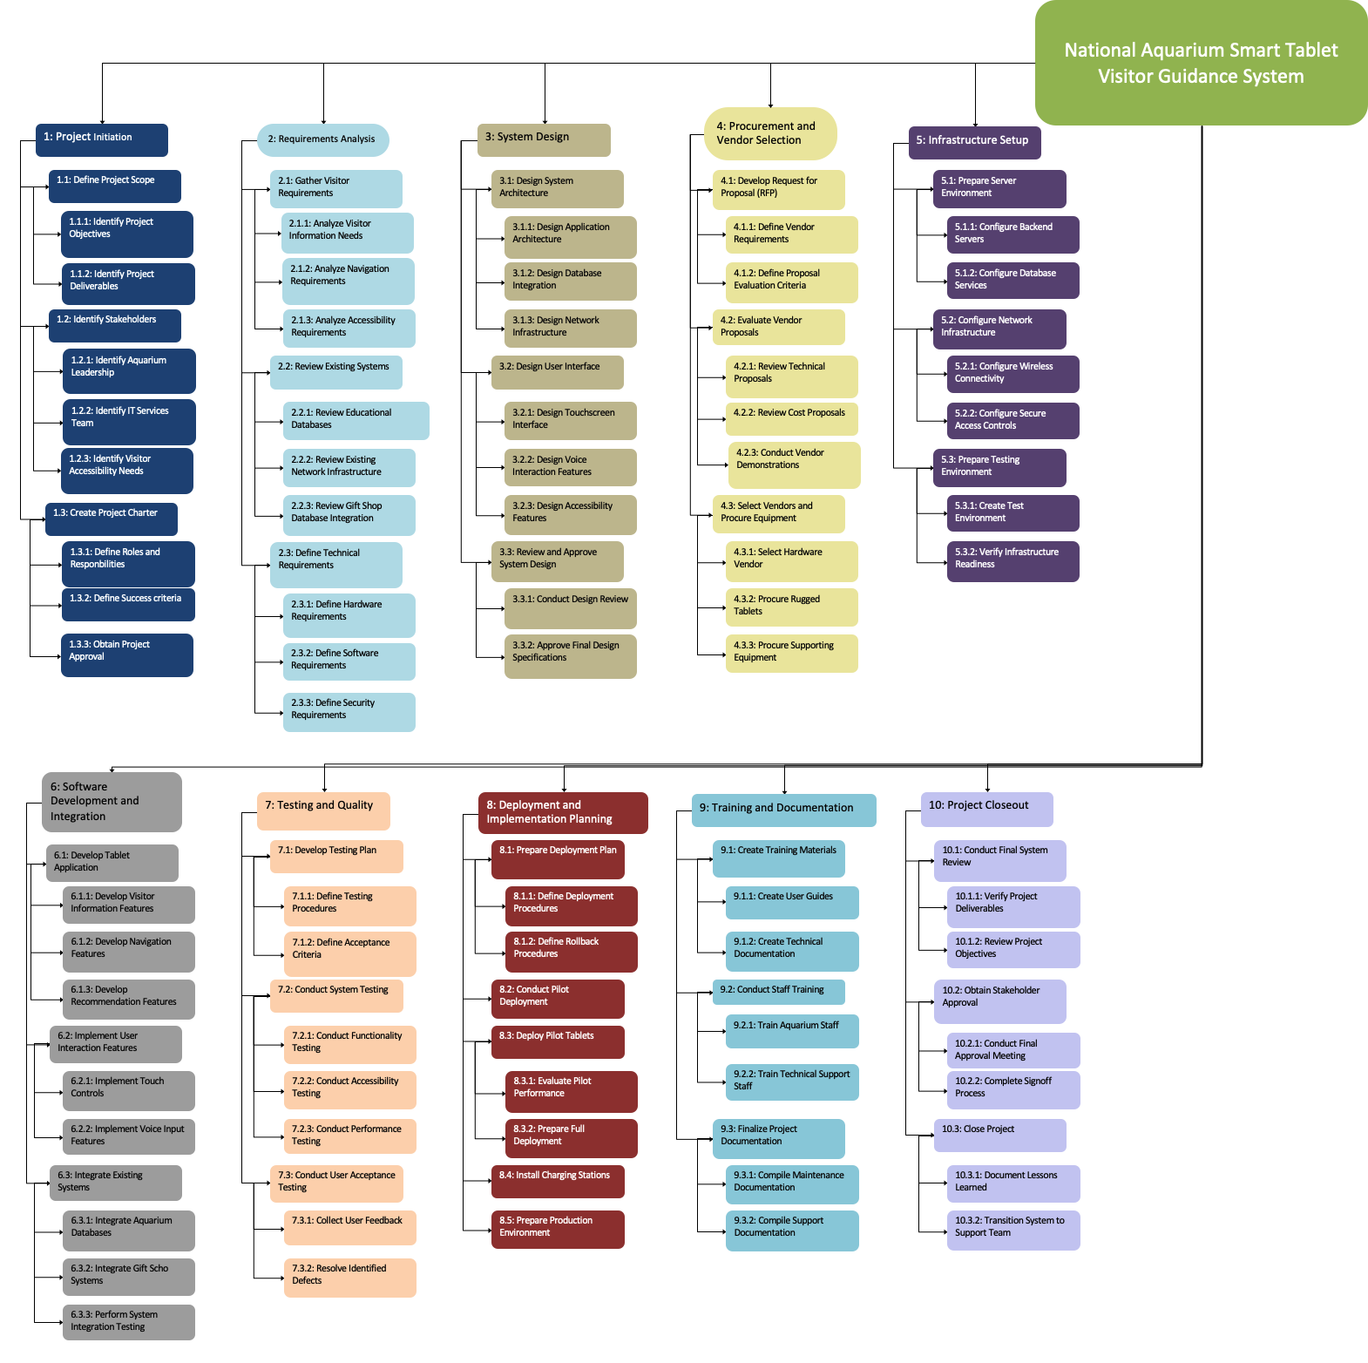

5.3 Task List

1.0 Project Initiation
The Project initiation begins the project task list of the National Aquarium Smart Tablet Visitor Guidance System. During this phase, deliverables, scope, and stakeholder expectations are documented. Stakeholders in this project include Aquarium Leadership, IT Services, and visitor accessibility groups. These stakeholders are identified to make sure that the project requirements align with the goals of visitor needs. The project charter is also made during this phase.
2.0 Requirements Analysis
This phase focuses on seeing the technical and operational needs of the Tablets. During this task list, the team finds information about visitor expectations, navigation functionality, accessibility accommodations, and other requirements. Existing systems, databases, and network infrastructure are then tested to see if there are any limitations. Hardware, software, and security requirements are also defined in this phase.

3.0 System Design
The system design phase focuses on creating the functionality of the Smart Tablet Guidance System. Here, the team designs the architecture, database, network requirements, and tablet interface. They then develop a plan for touchscreen controls and other features to make sure the system is simple for every visitor to use. Once the design is reviewed and approved, the project can then move on to procurement.

4.0 Vendor and Procurement
This phase focuses on getting the hardware, and other services needed. Here, the team makes a Request for Proposal (RFP), which describes the technical and operational requirements for the system. The Aquarium IT team will manage project planning, documentation, requirements, and final acceptance, while contracted vendors will provide the hardware. Solution quality, reliability, cost and support are required for proposal review.

5.0 Infrastructure Setup
The infrastructure setup phase is about preparing the technical environment to be able to support the system. During this phase, most of the technical application happens. Backend servers, database services, wireless connectivity, and security controls are all configured to support the system to make sure it's safe and reliable. Since the number of daily visitors is expected to be high, the network reliability and device communication are prioritized to ensure smooth operation daily. Completing this phase allows the project to continue to software development, integration, and testing.

6.0 Software Development and Integration
This phase focuses on building the system's software and connecting it with existing systems. During this part, the team develops the application, visitor information features, navigation tools, and recommendation functions. Voice input and touchscreen control were implemented to allow visitors with usability constraints to be able to use the tablets as well. Existing Aquarium databases and gift shop systems are also integrated to allow visitors to access real-time information through the facility. Once the development and integration are completed, the system is now ready for testing and quality review.

7.0 Testing
This phase focuses on verifying that the Smart Table system is reliable and meets requirements for the project. The team conducts many functionality, accessibility, usability, and performance tests across all of the major systems. User acceptance testing is also performed to make sure that the system is easy and effective and benefits the Aquarium visitors. Any defects or performance issues will be documented and resolved before deployment.

8.0 Deployment
Task 8 focuses on deployment and implementation planning, which is preparing the system for operational use. Here, deployment procedures, rollback plans, and installation requirements are finalized to support a smooth transition into production. A pilot deployment is used to evaluate system performance and to identify any remaining issues before full deployment. Charging stations, production environments, and supporting infrastructure are prepared using this phrase.

9.0 Training
The second-to-last phase is about training the staff to use the system. During this phase, procedures for maintenance, technical documentation, and support materials are created to make sure the future is feasible. Training sessions are now conducted to ensure the Aquarium employees and IT staff are familiar with the system and understand basic troubleshooting procedures. Documentation is also finalized to support long-term system management and future updates.

10.0 Project Closeout
Project closeout is considered the final phase. This is where the team reviews all deliverables and confirms that the objectives have been completed. Final approvals are gotten from Aquarium higher-ups and stakeholders, and the system is transitioned from being built to long-term operation support. Completion of this phase signifies successful delivery of the Smart Tablet Visitor Guidance System

5.4 Responsibility Matrix

Project Activity | Project Manager | System Architect | Backend Developer | UI/UX Designer | Integration Specialist | QA/Test Lead | Documentation Lead
Project Initiation | ✓ |  |  |  |  |  | ✓
Requirements Analysis | ✓ | ✓ | ✓ | ✓ | ✓ |  | ✓
System Design | ✓ | ✓ |  | ✓ | ✓
Procurement and Vendor Selection | ✓ |  |  |  | ✓ |  | ✓
Infrastructure Setup | ✓ | ✓ |  |  | ✓
Software Development and Integration | ✓ |  | ✓ |  | ✓
Testing and Quality Assurance | ✓ |  |  |  |  | ✓
Deployment and Implementation Planning | ✓ | ✓ |  |  | ✓ | ✓
Training and Documentation |  |  |  |  |  | ✓ | ✓
Project Closeout | ✓ |  |  |  |  |  | ✓

5.5 Resources

The national aquarium smart tablet visitor guidance system project will require a combination of personnel, hardware, software, networking infrastructure, and support resources to be able to successfully design, implement, and maintain the system. The following resources will support all phases of the project including planning, development, testing, deployment, and training.

Personnel Resources
- Project Manager
- System Architect
- Backend Developer
- UI/UX Designer
- Integration Specialist
- QA/Test Lead
- Documentation Lead
- Vendor Support Technicians
- Aquarium IT staff
- Employee Trainers

Hardware Resources
- Rugged Apple iPads/Tablets
- Protective tablet cases and accessories
- Charging and storage stations
- Wireless networking equipment
- Application and database servers
- Backup storage systems
- Testing workstations
Software Resources
- Mobile Device Management (MDM) software
- Database management systems
- Voice recognition software
- Navigation and mapping software
- Security and encryption software
- Application development tools
- API integration tools
- Testing and quality assurance software

Other Resources
- National Aquarium facility access
- Existing educational databases
- Aquarium exhibit maps and visitor information
- Training rooms and deployment areas
- Technical documentation and support materials

5.6 Schedule

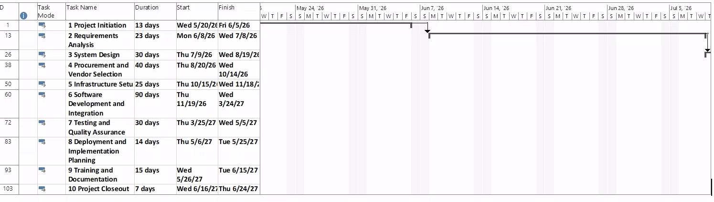
*Level 1 Items

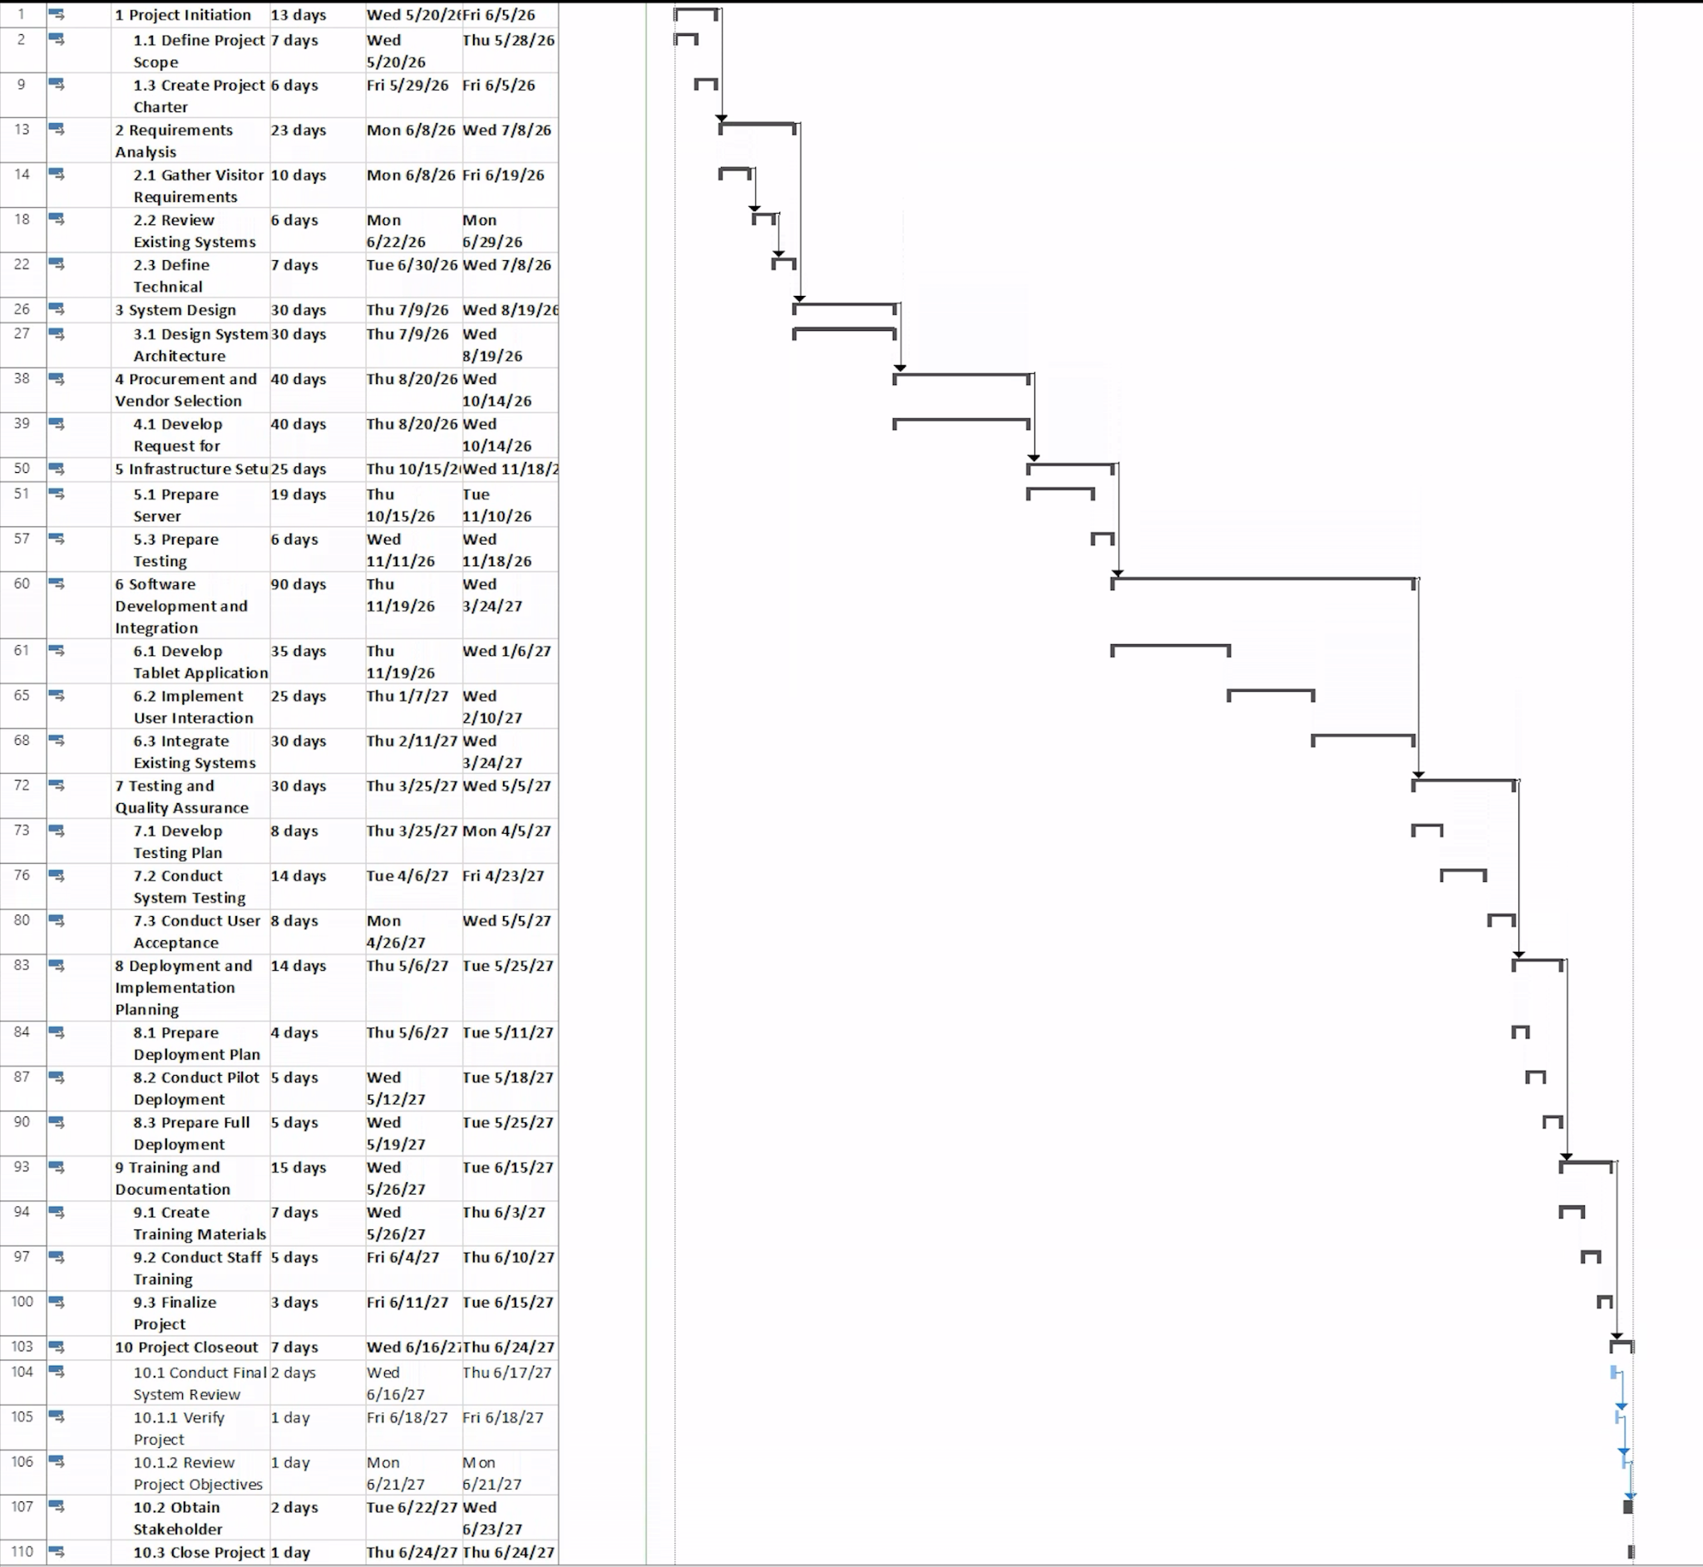

Level 2 Items

5.7 Cost Table

WBS Items | # Units/Hrs. | Cost/Unit/Hr. | Subtotals | WBS Level 2 Totals | % of Total
1. Project Management |  |  |  | $65,600 | 12%
Project Manager | 960 | $62 | $59,520
Documentation Lead | 160 | $38 | $6,080
2. Hardware and Infrastructure |  |  |  | $68,000 | 13%
Rugged tablets | 100 | $400 | $40,000
Protective cases/accessories | 100 | $100 | $10,000
Charging/storage stations | 1 | $8,000 | $8,000
Wireless network connectivity | 1 | $10,000 | $10,000
3. Software |  |  |  | $243,540 | 46%
Application software/tools | 1 | $8,000 | $8,000
Mobile device security software | 1 | $70,000 | $70,000
Database integration | 1 | $10,000 | $10,000
Software development* | 1 | $155,540 | $155,540
4. Integration |  |  |  | $13,000 | 2%
System integration | 1 | $13,000 | $13,000
5. Testing and Deployment |  |  |  | $25,000 | 5%
Testing and partial deployment | 1 | $5,000 | $5,000
QA/Test Lead labour | 400 | $50 | $20,000
6. Training and Support |  |  |  | $22,600 | 4%
Employee training/documentation | 1 | $5,000 | $5,000
Maintenance and support | 1 | $10,000 | $10,000
Documentation Lead support | 200 | $38 | $7,600
Subtotal |  |  | $437,740
7. Reserves / Contingency |  |  | $87,548 | $87,548 | 17%
Total project cost estimate |  |  |  | $525,288

5.8 Gantt Chart

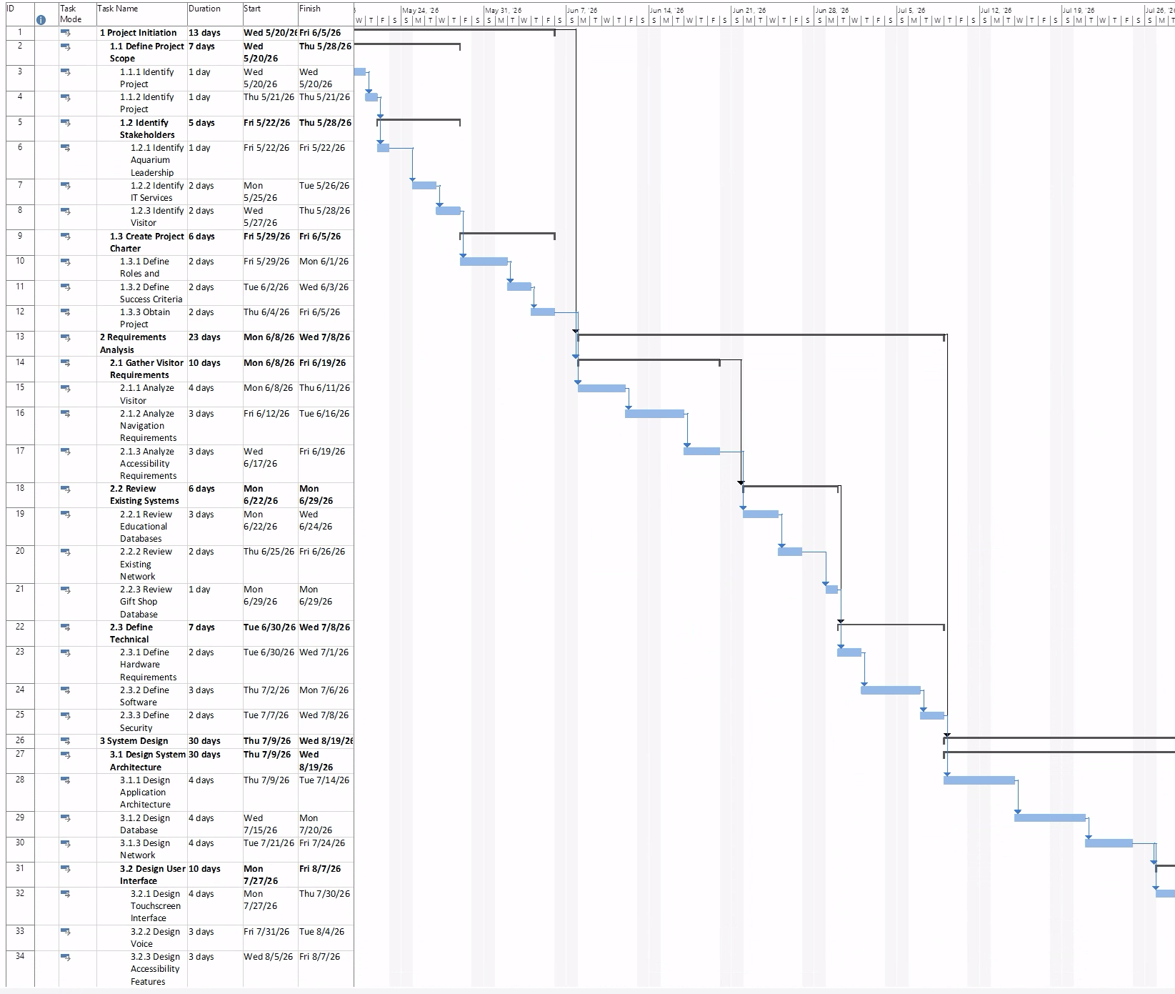
*Note, not full Gantt Chart as the full one is too large to format in document

5.9 Network Diagram

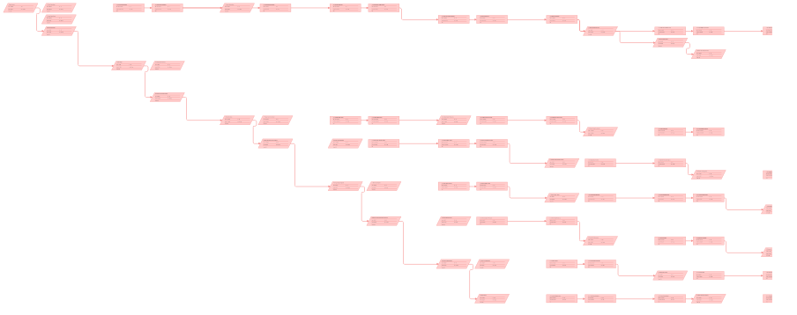

5.0 Critical Path

The critical path goes as follows:

- Project Initiation
- Requirements Analysis
- System Design
- Procurement and Vendor Selection
- Infrastructure setup
- Software development and integration
- Testing and quality assurance
- Deployment and implementation planning
- Training and Documentation
- Project Closeout

This would be the critical path due to there being little to no slack within the project. Also, each of the phases cannot be started on their own and there are prerequisites that must be met in order to continue down the path. Since there are no alternate routes to take during the project lifetime, any delay to the start time of these summary tasks would cause the project’s end date to be delayed.

Project Closeout
The National Aquarium Smart Tablet Visitor Guidance System project successfully delivered all planned project deliverables outlined within the project charter and scope statement. The completed deliverables include:
- Fully functional smart tablet application
- Rugged tablets with protective cases and charging stations
- Interactive exhibit and animal information system
- Indoor navigation and wayfinding functionality
- Voice and touch interaction capabilities
- Backend database integration with aquarium systems
- Gift shop recommendation integration
- Security and mobile device management configuration
- Testing and quality assurance reports
- Staff training sessions and training material
- Technical documentation and maintenance procedures
- System deployment and operational support plan
All deliverables were reviewed and approved by project stakeholders prior to final implementation.

Conclusion

Scope

The scope of the project is to create and implement a smart tablet system that can be used by visitors of the National Aquarium. Features of these systems will allow the visitors to gain information on exhibits, general facility features, and the ability to connect to the Aquarium store for future purposes. This scope does not include any physical or technical changes to the National Aquarium exhibiting IT services or physical facilities outside of tablet charging stations.

Time

The full launch date of the project will be May 20th, 2026. The National Aquarium is targeting a full deployment date of May 30th, 2027, at this current time. If the project expected end date has changed, either being delayed or finishing early, the project manager will notify the proper stakeholders.
Cost

At the current time the expected cost for the entire project sits at $525,288 as of May 2026. The project is a fixed price contract. Any changes to the project’s total cost will be documented and the proper stakeholders will be notified.

Procurement
The National Aquarium IT Services team will manage project planning, oversight, requirements, documentation, and final acceptance, while contracted vendors will provide hardware procurement, application development support, system integration, deployment assistance, and maintenance support.

